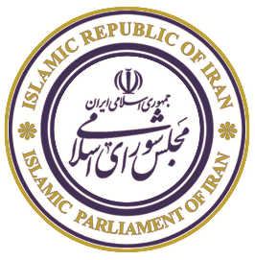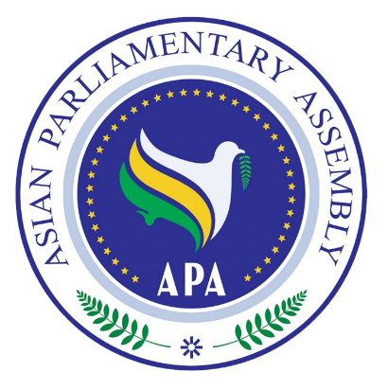

|  |  |  |
| --- | --- | --- |
|  | **ASIAN PARLIAMENTARY ASSEMBLY (APA)**  **The Meeting of APA Standing Committee on Political Affairs**  **Kosar Hotel, Isfahan, Iran**  **25 - 28 June 2019**  **Working Program** |  |

|  |  |
| --- | --- |
| **Tuesday, 25 June 2019** |  |
| All Day | Arrival of Delegations (Proceed to Kosar Hotel)  Accommodation & Registration |
| 16:30 – 20: 30 | City sightseeing and shopping |
| 21:00 | Dinner buffet by the Host Parliament  *Venue:* Zarrin Hall , Kosar Hotel |
| **Wednesday, 26 June 2019** |  |
| 07:00 – 08:30 | Breakfast |
| 08:30- 08: 45 | Arrival of delegations to the Meeting Hall  *Venue:* Cheshmandaz Neging Hall, Kosar Hotel |
| 09:00 – 10:00 | **Opening Ceremony**   * National Anthem  * Recitation from Holy Quran * Remarks by H.E. Dr. Abbas Rezaei, Governor General of Isfahan Province * Remarks by H.E. Dr. Seyedeh Fatemeh Zolghadr, Head of APA delegation of Islamic Parliament of Iran * Remarks by H.E. Ms. Asuman Erdoğan, Rep. of APA President * Remarks by H.E. Dr. Mohammad Reza Majidi, APA Secretary General * Remarks by H.E. Dr. Masoud Pezeshkian First Vice-Speaker of the Islamic Parliament of Iran   *Venue:* Cheshmandaz Neging Hall, , Kosar Hotel |
| 10:00 – 10:30 | Photo Session & Tea/Coffee Break |
| 10:30 – 13: 00 | **Meeting of the Standing Committee on Political Affairs**  - Adoption of the Agenda  - Election of Bureau (Vice-Chair, Rapporteur)  - Opening remarks by the Chairman  - Report by the APA Secretary General  - Consideration of draft resolutions:   * Draft Resolution on Towards an Asian Parliament. * Draft Resolution on Good Governance. * Draft Resolution on Rule of Law and Judicial Empowerment. * Draft Resolution on Good Parliamentary Practices. * Draft Resolution on Building Prosperity in Asia through Friendship and Cooperation. * Draft Resolution on Asian Parliaments and Governments Together for Prosperity in Asia. * Draft Resolution on Asian Parliaments’ Unwavering Support for the Palestinian People. * Draft Resolution on Harmonious Development through Democracy * New Draft Resolution on Enhancing Cooperation among the Members of the Asian Parliamentary Assembly to Protect and Promote Multilateralism   *Venue:* Cheshmandaz Neging Hall, , Kosar Hotel |
| 13:00 – 14:30 | Lunch  *Venue:* Zarrin Hall ,Kosar Hotel |
| 14:30 – 16:00 | **Working Group meeting on Asian Parliament**  *Venue:* Cheshmandaz Neging Hall, , Kosar Hotel |
| 16:00 – 17:00 | Tea/Coffee Break |
| 17:00 – 18:00 | Closing Session (Adoption of Final Report) |
| 20:00 | Dinner hosted by H.E Dr. Abbas Rezaei, Governor General of Isfahan Province  *Venue:*Zarrin Hall ,Kosar Hotel |
|  |  |
| **Thursday, 27 June 2019** |  |
| 08:30 – 18:00 | **Cultural Program:** |
| 13:00 | Launch Reception by the Isfahan Mayor  *Venue: Abbassi Hotel* |
| 19:00 | * Meeting with Economic Entrepreneurs * Dinner hosted by Isfahan Chamber of Commerce, Industry, Mines and Agriculture   *Venue: Chamber of Commerce* |
|  |  |
| **Friday, 28 June 2019** |  |
| All Day | Departure of Delegations |

Edition: 2019-06-25